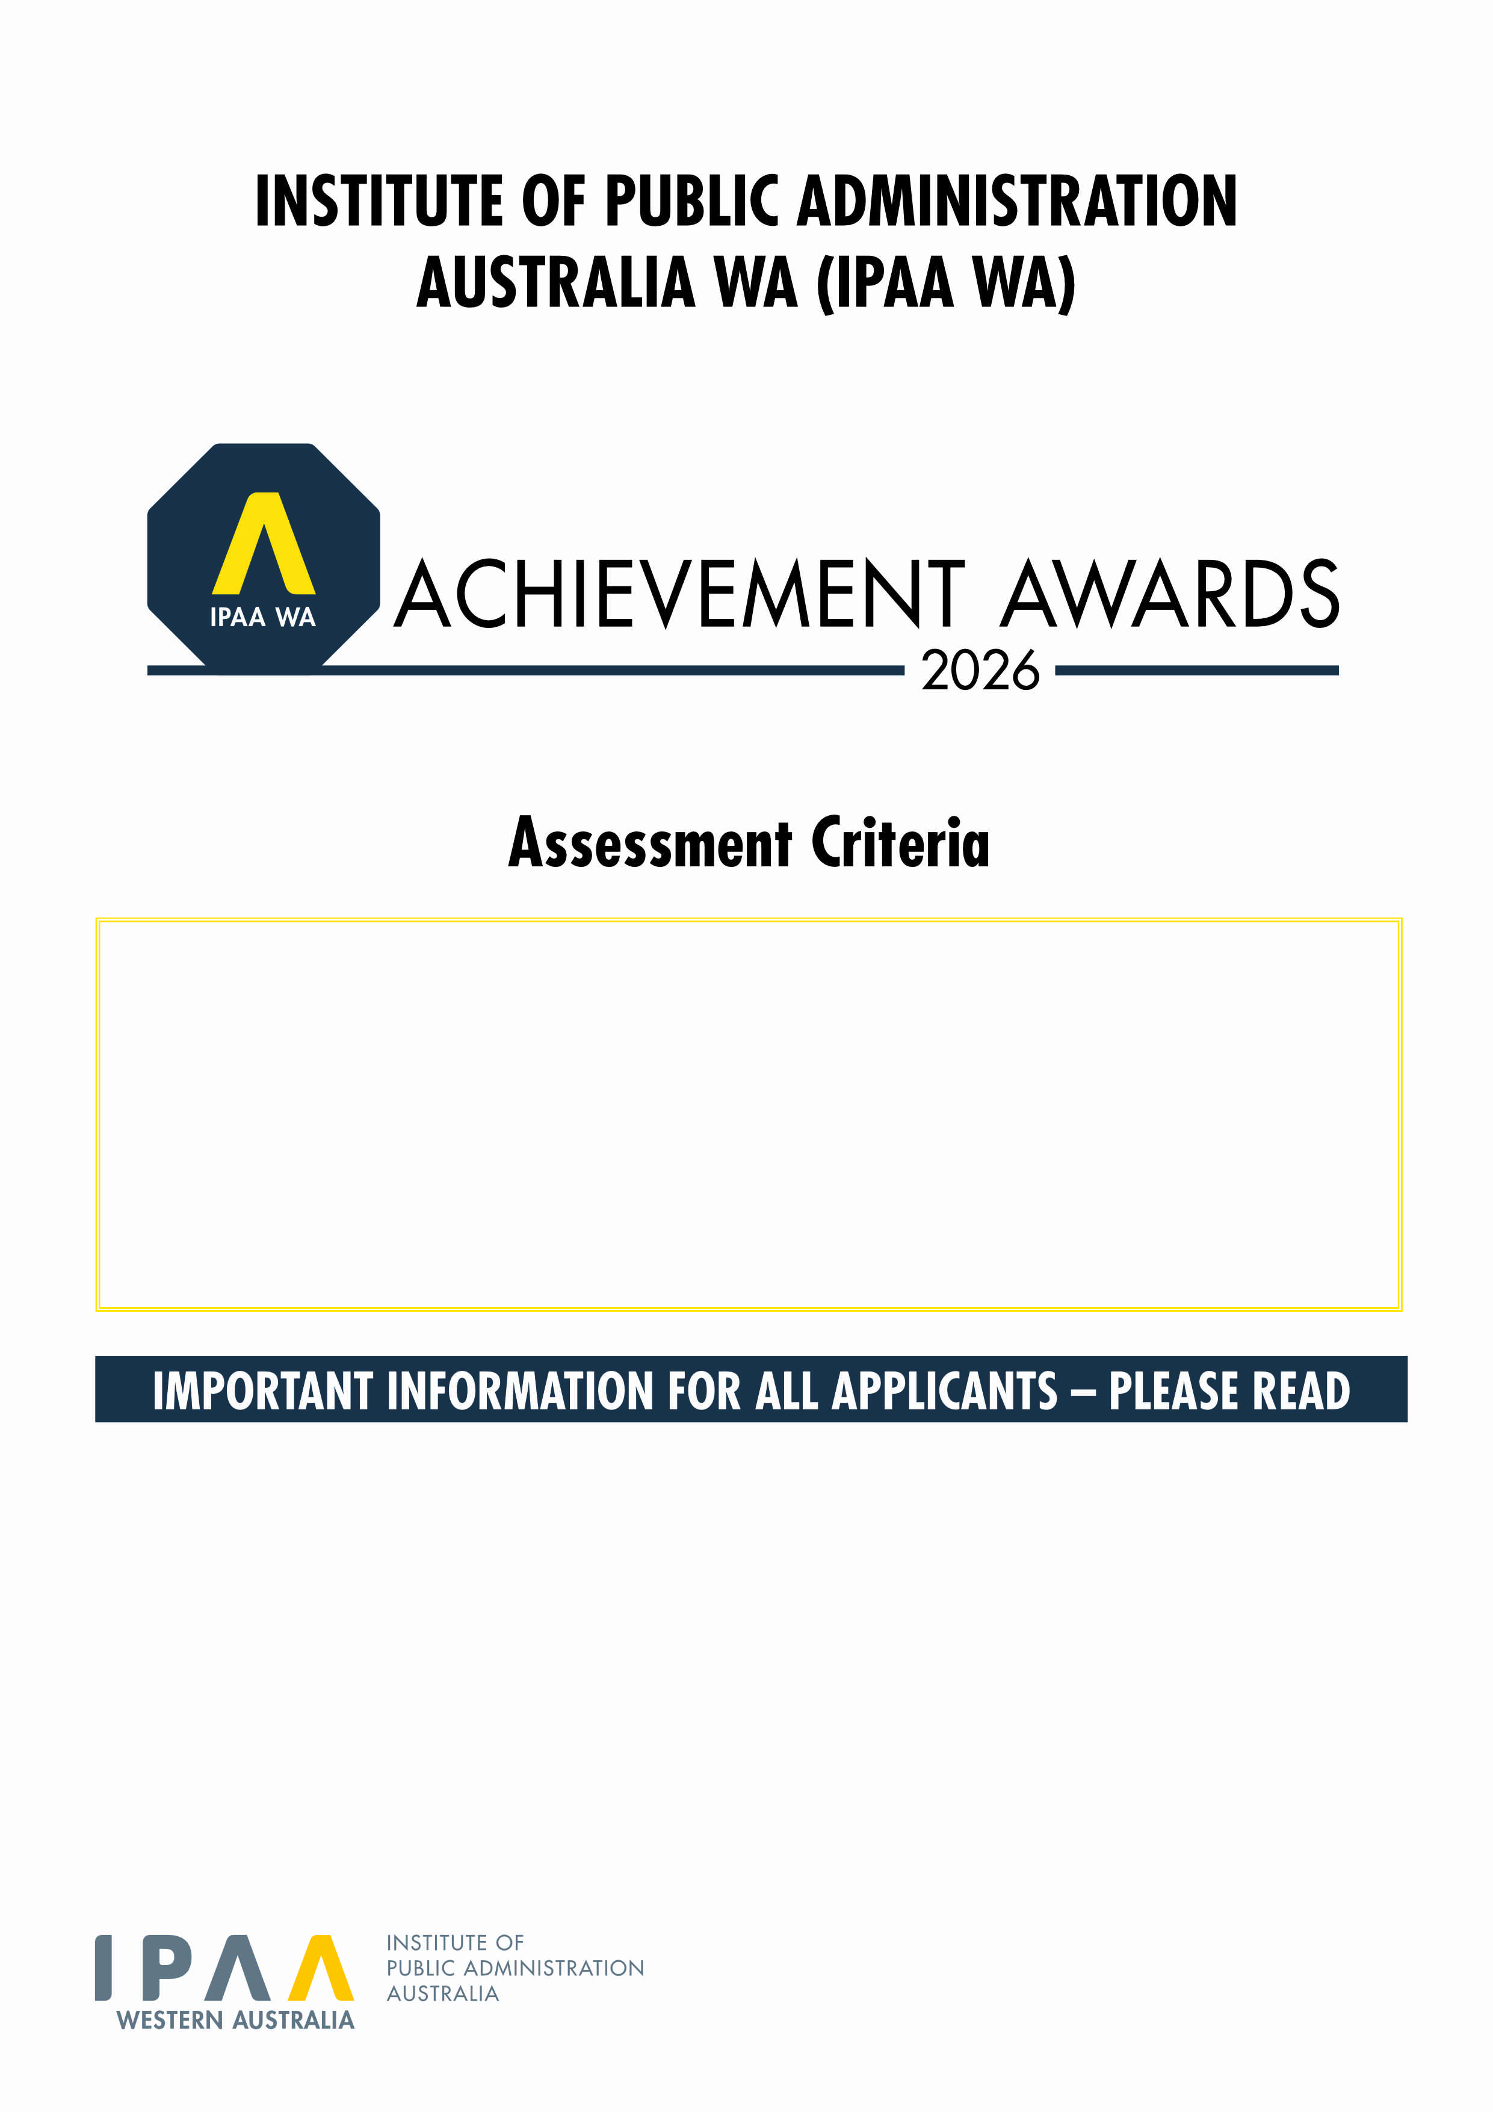
- Please do not exceed the maximum word count per criteria (additional words will not be considered).
- Each Criteria is placed on a separate page. This award has 4 Criteria (C1 to C4) - ensure you address all criteria.
- If you are including graphics/images/tables, we ask that you do not exceed a page count for that particular criteria, based on 500 words per page as a guide (e.g. if the criteria is 1,000 words, this would give you two pages maximum).
- Please keep the default size 11 Arial font when addressing the criteria.
- Once you have addressed all criteria in this form, please upload this document via the online Entry Form: https://www.wa.ipaa.org.au/awards-scholarships/achievement-awards/online-entry-form/
- Email awards@ipaawa.org.au or phone 08 9360 1400 for enquiries or assistance completing the Assessment Criteria.

Leader of the Year working within a Division, Team or Organisation

Criteria 1: Weighting - 10% | Maximum 300 Words

C1: Provide a summary of the nominee’s leadership philosophy and the principles they bring to their organisation.

Criteria 2: Weighting - 30% | Maximum 700 Words

C2: Outline how the nominee has improved the effectiveness of their area of responsibility in; service delivery to their community or industry sector or contributed to the general goals of the organisation as a whole.

Criteria 3: Weighting - 50% | Maximum 1,000 Words

C3: Describe how the nominee has demonstrated excellence in administration, management and/or leadership throughout their career, focusing on recent years, including how the nominee promotes, encourages, and/or develops others.

Criteria 4: Weighting - 10% | Maximum 300 Words

C4: Using examples, demonstrate how the nominee’s division, team or organisation exhibits best practice in public administration as a result of the nominee’s leadership.

